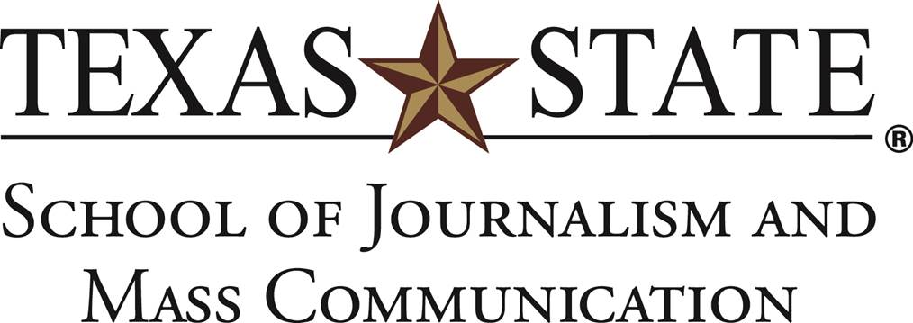

**Overview**

The School of Journalism and Mass Communication, housed in historic Old Main, offers a nationally accredited curriculum that introduces students to the broad framework of mass communication, emphasizing what is common and fundamental to advertising, journalism, public relations, electronic media and online digital media.

**Mission statement**

*The mission of the School of Journalism and Mass Communication is to pursue excellence. Our programs strive to cultivate strong professional, research, theoretical, critical and ethical skills in a diverse and engaging environment that prepares students to be socially responsible media professionals, scholars and citizens.*

**Social Networks**

The School of Journalism and Mass Communication is currently active on Facebook, Twitter and Instagram, and we maintain a regularly updated blog on Wordpress.

Facebook: 1,406 fans | Twitter: 4,205 followers | Instagram: 967 followers

**Audience**

Our social audiences consist of four main components: current students, former students, faculty/staff and parents. Here are some demographics from Facebook analytics:  
64% of audience is female  
53.5% of audience is 18-34

Nearly half of the audience lives along the I-35 corridor

**Goals**

1. Showcase student work
2. Showcase faculty
3. Inform students of opportunities
4. Grow our audience
5. Attract new students



**Social Media Content**

Let’s create some content for Instagram! Remember, content on this platform carries expectation of quality photos, creative captions, relevant hashtags and geo-tags.

First, create an Instagram account, if you don’t have one already. (It can be a dummy account if you don’t want to be on the platform. Feel free to tag along with an experienced Instagram user if you feel like you’ll need some help along the way.)

Take the next 30 minutes to roam Old Main and/or campus. While you’re out, collect as much content as needed to accomplish the following goals:

* Post two photos and captions. (Remember to explore relevant hashtags and use geotagging. If you feel up for it, make the second photo a photo album. Tag Texas State University in any pictures that show off the campus. Tag SJMC for any photos about the School of Journalism and Mass Communication.)
* A four-part Instagram Stories story. Use the platform to tell a story with a beginning, middle and end. You can use photos, video or a combination of both. (We realize many of you have likely not used Instagram Stories before. Get creative! Use location tags, emojis, etc.)

Once you’re back and finished with your posts, submit your Instagram username to the Slack channel. That way we can view everyone’s work.



**Social Media Analytics Report**

Using Canva or InDesign and the data pulled from the School of Journalism and Mass Communication’s Facebook Insights, create a social media analytics report for 30 days (April 10-May 10). Provide the following information:

* Client logo, title and date range
* Number of page likes
* Average post reactions
* Average post comments
* Average post shares
* Most successful post and why

Also provide some basic demographic information from Insights:

* Gender breakdown
* Most popular age groups
* Where our fans live
* When our fans are online